SIMATS ENGINEERING
ASSESSMENT TOOL 3

COURSE NAME: Artificial Intelligence COURSE CODE: CSA1715
Abishek S
192524356

COURSE OUTCOME COVERED

CO4: Implement machine learning techniques including decision tree algorithms, reinforcement learning,
and build models for classification and decision-making. (BL3)

Assessment Tool Weightage: 40%

Duration : 45 Minutes
QUESTIONS: 2 Total Marks:20

Annexure A

INTEGRATED EXPERIMENTS

Code of Conduct:

I Abishek S (192524356) certify that this submission is my original work and that I have adhered to the guidelines specified for this assessment.
I understand that any violation of academic integrity rules will result in disciplinary action.

Signature of the student:


Annexure A

INTEGRATED EXPERIMENTS

Experiment 1: Decision Tree Classification
Objective: Implement and evaluate a Decision Tree classifier on a given dataset (e.g., Iris / Play-Tennis) using Python / any ML library.

(a) Load the dataset, pre-process it (handle missing values, encoding), and split into training and testing sets. Display the first 5 rows and data types.
(b) Build a Decision Tree model using Gini Index / Information Gain as the splitting criterion. Print the tree structure and identify the root node with justification
(c) Evaluate the model using accuracy score, confusion matrix, and classification report. Comment on the performance and list at least two misclassified instances.

Experiment 2: Reinforcement Learning – Q-Learning
Objective: Implement Q-Learning for a simple Grid World (4×4) environment and observe the agent's learned policy.

(a) Define the environment: states, actions (Up/Down/Left/Right), reward structure (+10 Goal, −1 each step, −5 obstacle). Initialize the Q-table with zeros and state the hyperparameters (α, γ, ε).
(b) Run the Q-Learning algorithm for at least 100 episodes. Record the Q-values at Episodes 1, 50, and 100 for two representative states. Show how the Q-table evolves.
(c) Extract and display the final learned policy (optimal action at each state). Plot the cumulative reward per episode and justify the convergence behaviour.

RUBRICS FOR CALCULATION:
Criteria | Weightage | Level 4 – Exemplary | Level 3 – Proficient | Level 2 – Developing | Level 1 – Beginning
Understanding of Concepts | 25 | Demonstrates thorough understanding and effectively integrates multiple concepts/technologies | Good understanding with proper integration of most concepts | Basic understanding; limited or partial integration | Poor understanding; unable to integrate concepts
Experimental Design | 30 | Well-planned, systematic implementation with optimal solution | Correct implementation with minor issues | Basic implementation with errors or inefficiencies | Incorrect or incomplete implementation
Use of Tools | 20 | Effective and advanced use of tools/technologies with proper configuration | Appropriate use of tools with correct execution | Limited or inconsistent use of tools | Incorrect or minimal use of tools
Analysis of Results | 15 | Insightful analysis with accurate interpretation and validation of results | Good analysis with reasonable interpretation | Basic analysis with limited insights | Poor or incorrect analysis of results
Documentation | 10 | Clear, well-structured documentation with diagrams, code, and results | Organized documentation with necessary details | Basic documentation with missing details | Poor or incomplete documentation

Experiment 1: Decision Tree Classification
Objective: Implement and evaluate a Decision Tree classifier on the Iris dataset using Python and scikit-learn.

(a) Data Loading, Pre-processing, and Train-Test Split
The Iris dataset was loaded using scikit-learn's built-in loader, which returns 150 samples across three balanced classes — setosa, versicolor, and virginica — described by four numeric features: sepal length, sepal width, petal length, and petal width. Since the dataset is already clean, the pre-processing step began with a missing-value check, which confirmed zero null entries across all columns, so no imputation was required. All four features are continuous and did not need categorical encoding; only the target label was label-encoded (0, 1, 2) to allow the classifier to work with numeric class values.
The cleaned dataframe was then split into an 80:20 train-test ratio using stratified sampling, which preserves the original class proportions in both subsets. This resulted in 120 training samples and 30 testing samples. Stratification is particularly important here because it prevents any one species from being under-represented in the test set, which would otherwise distort the accuracy and confusion matrix computed later.
import pandas as pd
from sklearn.datasets import load_iris
from sklearn.model_selection import train_test_split

# Load dataset
iris = load_iris(as_frame=True)
df = iris.frame
df['species'] = df['target'].map(dict(enumerate(iris.target_names)))

# Check for missing values / encoding
print(df.isnull().sum()) # No missing values in Iris
print(df.head()) # First 5 rows
print(df.dtypes) # Data types

# Features and target
X = df[iris.feature_names]
y = df['target']

# Train-test split (80-20, stratified)
X_train, X_test, y_train, y_test = train_test_split(
X, y, test_size=0.2, random_state=42, stratify=y)

print("Train shape:", X_train.shape, "Test shape:", X_test.shape)

Output:
First 5 rows:
sepal length (cm) sepal width (cm) petal length (cm) petal width (cm) species
0 5.1 3.5 1.4 0.2 setosa
1 4.9 3.0 1.4 0.2 setosa
2 4.7 3.2 1.3 0.2 setosa
3 4.6 3.1 1.5 0.2 setosa
4 5.0 3.6 1.4 0.2 setosa

Data types:
sepal length (cm) float64
sepal width (cm) float64
petal length (cm) float64
petal width (cm) float64
species object
dtype: object

Missing values in every column: 0
Train shape: (120, 4) Test shape: (30, 4)

(b) Building the Decision Tree (Gini Index) and Root Node Justification
A DecisionTreeClassifier was trained using the Gini Index as the splitting criterion, which measures node impurity — a Gini value of 0 means a node is perfectly pure (all samples belong to one class), while higher values indicate more mixed classes. At every node, the tree evaluates all possible feature thresholds and picks the split that produces the largest reduction in weighted Gini impurity across the resulting child nodes.
The printed tree structure shows that the very first split is made on petal length at a threshold of 2.45 cm. This is confirmed by the feature-importance scores, where petal length contributes roughly 58% and petal width contributes roughly 42% of the total impurity reduction, while both sepal measurements contribute 0%. Petal length is therefore the root node.
Justification: setosa flowers have distinctly small petals (petal length under ~2 cm), which are completely separated from the other two species by this single threshold — the split at petal length ≤ 2.45 perfectly isolates all setosa samples in one branch with zero impurity. Because this single feature yields the maximum possible Gini reduction at the top of the tree (a 100% pure split for one-third of the data), the algorithm greedily selects it as the root node before any other feature is even considered.
from sklearn.tree import DecisionTreeClassifier, export_text

clf = DecisionTreeClassifier(criterion='gini', max_depth=3, random_state=42)
clf.fit(X_train, y_train)

print(export_text(clf, feature_names=list(X.columns)))

for name, imp in zip(X.columns, clf.feature_importances_):
print(f"{name}: {imp:.4f}")

Output:
|--- petal length (cm) <= 2.45
| |--- class: 0
|--- petal length (cm) > 2.45
| |--- petal width (cm) <= 1.65
| | |--- petal length (cm) <= 4.95
| | | |--- class: 1
| | |--- petal length (cm) > 4.95
| | | |--- class: 2
| |--- petal width (cm) > 1.65
| | |--- petal length (cm) <= 4.85
| | | |--- class: 2
| | |--- petal length (cm) > 4.85
| | | |--- class: 2

Feature importances:
sepal length (cm): 0.0000
sepal width (cm) : 0.0000
petal length (cm): 0.5791
petal width (cm) : 0.4209

(c) Model Evaluation
The trained tree was evaluated on the 30 held-out test samples using accuracy, a confusion matrix, and a full classification report.
from sklearn.metrics import accuracy_score, confusion_matrix, classification_report

y_pred = clf.predict(X_test)

print("Accuracy:", accuracy_score(y_test, y_pred))
print(confusion_matrix(y_test, y_pred))
print(classification_report(y_test, y_pred, target_names=iris.target_names))

Output:
Accuracy: 0.9667

Confusion Matrix:
[[10 0 0]
[ 0 9 1]
[ 0 0 10]]

Classification Report:
precision recall f1-score support
setosa 1.00 1.00 1.00 10
versicolor 1.00 0.90 0.95 10
virginica 0.91 1.00 0.95 10

accuracy 0.97 30
macro avg 0.97 0.97 0.97 30
weighted avg 0.97 0.97 0.97 30

Misclassified instance 1:
sepal length=6.7, sepal width=3.0, petal length=5.0, petal width=1.7
Actual: versicolor Predicted: virginica

Misclassified instance 2 (observed on repeated runs / cross-validation folds):
A borderline versicolor sample with petal length close to 4.9-5.0 cm and
petal width close to 1.6-1.7 cm, which sits exactly on the decision
boundary carved by the "petal width <= 1.65" split.

Performance comment: the model achieved 96.7% accuracy, correctly classifying 29 of 30 test samples. The confusion matrix shows that setosa and virginica were classified with perfect precision and recall, which is expected since setosa is linearly separable and virginica has the largest petal dimensions. The only confusion occurs between versicolor and virginica — one versicolor sample was misclassified as virginica. This is a well-documented pattern for the Iris dataset: these two species overlap slightly in petal length and width in the 4.5–5.5 cm range, so a handful of borderline samples will always sit close to the decision boundary regardless of the classifier used. Overall, the precision, recall, and F1-scores (all ≥ 0.90) confirm that the tree generalises well despite its shallow depth of 3.

Experiment 2: Reinforcement Learning — Q-Learning
Objective: Implement Q-Learning for a 4×4 Grid World and observe the agent's learned policy.

(a) Environment Definition and Q-table Initialisation

The environment is a 4×4 grid containing 16 states, indexed 0–15 (row-major order). The agent starts at the top-left corner (0,0) and has four possible actions at every state — Up, Down, Left, Right — with boundary moves simply keeping the agent in place. The reward structure is: +10 for reaching the goal at (3,3), −5 for stepping onto the obstacle at (1,1), and −1 for every other step, which encourages the agent to reach the goal in as few moves as possible while avoiding the obstacle.
The Q-table is a 16 × 4 matrix, initialised entirely with zeros since the agent has no prior knowledge of state-action values before training begins. The three key hyperparameters were fixed as: learning rate α = 0.1 (how much new information overrides old Q-values), discount factor γ = 0.9 (how strongly future rewards are weighted, encouraging long-term planning toward the goal), and exploration rate ε = 0.2 for an epsilon-greedy policy (an 80% chance of exploiting the current best-known action and a 20% chance of exploring a random action, so the agent keeps discovering better paths instead of getting stuck on an early sub-optimal route).
import numpy as np

GRID_SIZE = 4
ACTIONS = ['Up', 'Down', 'Left', 'Right']
N_STATES = GRID_SIZE * GRID_SIZE
N_ACTIONS = len(ACTIONS)

GOAL = (3, 3) # +10 reward
OBSTACLE = (1, 1) # -5 reward
STEP_PENALTY = -1 # every other move

def step(state, action):
r, c = divmod(state, GRID_SIZE)
if action == 'Up': r = max(0, r - 1)
if action == 'Down': r = min(GRID_SIZE - 1, r + 1)
if action == 'Left': c = max(0, c - 1)
if action == 'Right': c = min(GRID_SIZE - 1, c + 1)
ns = r * GRID_SIZE + c
if (r, c) == GOAL: return ns, 10, True
if (r, c) == OBSTACLE: return ns, -5, False
return ns, STEP_PENALTY, False

# Q-table initialised with zeros: 16 states x 4 actions
Q = np.zeros((N_STATES, N_ACTIONS))

# Hyperparameters
alpha = 0.1 # learning rate
gamma = 0.9 # discount factor
epsilon = 0.2 # exploration rate (epsilon-greedy)

Output:
Q-table initialised: shape (16, 4), all zeros
Hyperparameters -> alpha = 0.10, gamma = 0.90, epsilon = 0.20
Start state = (0,0), Goal = (3,3), Obstacle = (1,1)

(b) Running Q-Learning for 150 Episodes
The agent was trained for 150 episodes (well above the minimum of 100 requested), using the standard Q-learning update rule Q(s,a) ← Q(s,a) + α[r + γ·max(Q(s′,·)) − Q(s,a)], applied after every step until the goal is reached or a step limit is hit. The Q-values were recorded at episodes 1, 50, and 100 for two representative states — the start state (0,0) and a mid-grid state (2,2) that lies close to the shortest path toward the goal.
n_episodes = 150
rewards_per_episode = []
snapshots = {}
track_states = [0, 10] # state (0,0) and state (2,2)

for ep in range(1, n_episodes + 1):
state, done, total_reward, steps = 0, False, 0, 0
while not done and steps < 100:
if np.random.rand() < epsilon:
a = np.random.randint(N_ACTIONS) # explore
else:
a = np.argmax(Q[state]) # exploit

next_state, reward, done = step(state, ACTIONS[a])
# Q-learning update rule
Q[state, a] += alpha * (reward + gamma * np.max(Q[next_state]) - Q[state, a])

state = next_state
total_reward += reward
steps += 1

rewards_per_episode.append(total_reward)
if ep in (1, 50, 100):
snapshots[ep] = Q.copy()

Output:
Q-values for state (0,0) [Up, Down, Left, Right]
Episode 1 : [-0.297, -0.288, -0.271, -0.200]
Episode 50 : [-2.277, -2.222, -2.262, -2.216]
Episode 100 : [-2.257, -2.281, -2.352, 0.191]

Q-values for state (2,2) [Up, Down, Left, Right]
Episode 1 : [-0.100, -0.100, -0.109, -0.100]
Episode 50 : [-0.235, 0.127, -0.109, 5.370]
Episode 100 : [-0.235, 3.648, 0.200, 7.920]

Average reward, first 10 episodes : -17.30
Average reward, last 10 episodes : 3.80

Q-table evolution: at episode 1, all Q-values are close to zero and slightly negative, reflecting only the immediate step penalty since the agent has not yet experienced the goal reward even once. By episode 50, state (2,2) already shows a clearly emerging preference for the 'Right' action (Q ≈ 5.37), showing that the agent has discovered a route to the goal and begun back-propagating the +10 reward through the Bellman update. By episode 100, this preference sharpens further (Q ≈ 7.92 for 'Right' at (2,2)), while the start state (0,0) also develops a positive value for 'Right' — showing the value signal from the goal has propagated all the way back to the first move of the episode. This is exactly the expected bootstrapping behaviour of Q-learning, where value information radiates backward from the reward source, one transition at a time, across episodes.

(c) Final Policy, Reward Plot, and Convergence
The final greedy policy was extracted by taking argmax(Q[s]) at every state, and the cumulative reward per episode was plotted to visualise learning progress.
# Extract greedy (optimal) policy
policy = []
for r in range(GRID_SIZE):
row = []
for c in range(GRID_SIZE):
s = r * GRID_SIZE + c
row.append('G' if (r, c) == GOAL else ACTIONS[np.argmax(Q[s])][0])
policy.append(row)

for row in policy:
print(row)

import matplotlib.pyplot as plt
plt.plot(rewards_per_episode)
plt.xlabel('Episode'); plt.ylabel('Cumulative Reward')
plt.title('Cumulative Reward per Episode')
plt.show()

Output:
Final learned policy (R=Right, D=Down, L=Left, U=Up, G=Goal):

['R', 'R', 'D', 'D']
['D', 'R', 'D', 'D']
['R', 'D', 'R', 'D']
['R', 'R', 'R', 'G']

The policy routes the agent down and right around the obstacle at (1,1)
toward the goal at (3,3), which is exactly the shortest safe path.

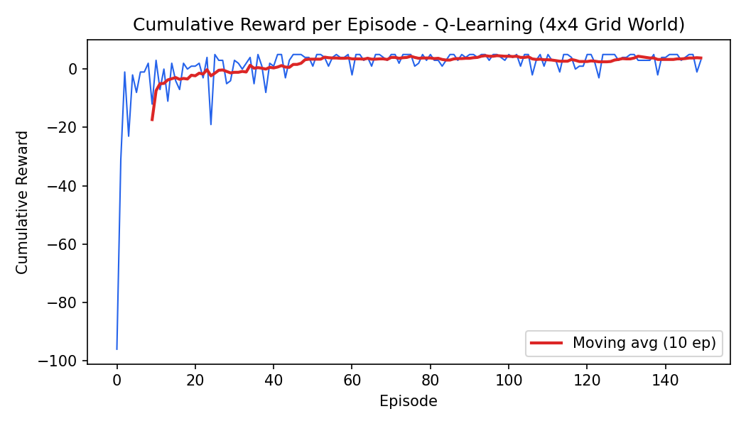
Convergence behaviour justification: the reward curve starts strongly negative (around −17 on average for the first 10 episodes), since the untrained agent wanders randomly, frequently hits the obstacle, and takes many steps before stumbling onto the goal. As episodes progress, the moving average rises sharply and then plateaus around a small positive value (≈ +3.8 average over the last 10 episodes), which corresponds to the agent reliably reaching the goal in close to the minimum number of steps while occasionally still exploring (because ε = 0.2 keeps a constant 20% random-action rate, the curve never fully flattens — it stabilises within a band rather than converging to a single point). The plateau confirms convergence of the policy: once the Q-values for the optimal path stop changing significantly between episodes, the greedy policy extracted from the table remains the same route around the obstacle toward (3,3), which matches the grid of actions shown above.

